

Joylan E. Panungcat

BSIT 4A

IT 411-System Integration and Architecture

**System Development Life Cycle (SDLC)**

1. **Predictive Approach**

A predictive approach to deal with the SDLC is a methodology that expects that the improvement task can be arranged and coordinated ahead of time and that the new data framework can be created by the arrangement. A predictive SDLC's are useful for a building system that is well understood and defined [1].

**Waterfall Model**

The SDLC approach that is farthest to the left on the predictive/adaptive scale that is most predictive is called a waterfall model. It is an SDLC approach that assumes the various phases of a project can be completed sequentially, one phase leads into the next phase. A detailed plan is first developed, then the requirements are thoroughly specified, then the system is designed to the last algorithm, then it is programmed, tested and installed [1].

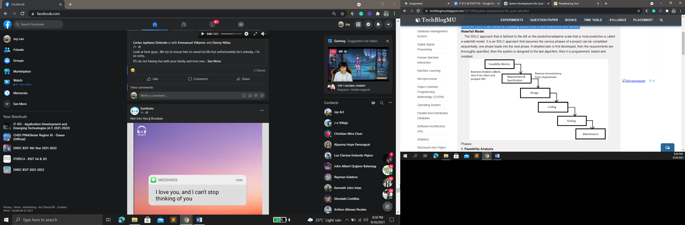The Phrases of a predictive SDLC approach [2]:

1. **Feasibility Analysis**

The current framework is assessed. Insufficiencies are recognized. This should be possible by meeting clients of the framework and talking with help work force

1. **Plan and requirements:**

The new system requirements are defined. In particular, the deficiencies in the existing system must be addressed with specific proposals for improvement. Other factors defined include needed features, functions and capabilities.

1. **Design:**

The proposed framework is planned. Plans are spread out concerning the actual development, equipment, working frameworks, programming, correspondences and security issues

1. **Development**

The new system is developed. The new components and programs must be obtained and installed. Users of the system must be trained in its use.

1. **Testing**

Testing the system whether it works successfully or not.

1. **Deployment**

The system is incorporated in a production environment. This can be done in various ways. The new system can be phased in, according to application or location, and the old system gradually replaced.

1. **Maintenance**

After the system or project has been developed it is mandatory to maintain it to keep update time to time.

1. **Adaptive Approach**

An SDLC approach that is more flexible assuming that the project cannot be planned out completely in advance but must be modified as it progress. Some requirements of the system may yet need to be determined, after some preliminary development work [1].

**Spiral Model**

The spiral model combines the idea of iterative development with the systematic, controlled aspects of the waterfall model. This Spiral model is a combination of iterative development process model and sequential linear development model i.e. the waterfall model with a very high emphasis on risk analysis. It allows incremental releases of the product or incremental refinement through each iteration around the spiral [4].

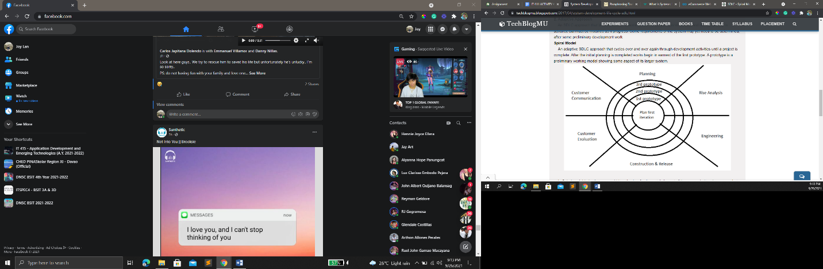

In Spiral model (adaptive approach) iteration is a fundamental element of the approach. Iteration means that work-activities analysis, design, implementation are done once, then again and yet again they are repeated. With each iteration, the developers refine the result so that it is clear to what is ultimately needed [1].

**Successful projects implemented using the SDLC models:**

* **ProjectManager.com –** the online project tool used to plan over 2 million projects using the waterfall model in sdlc [3].
* **Pair programming** - Pair programming is an Agile software development technique originating from Extreme programming (XP) in which two developers or programmers sharing a single workstation (one screen, keyboard and mouse among the pair).

**14 Best Tools for Remote Pair Programming [5].**

* Motepair by Atom
* Tuple
* Teletype for atom
* . Microsoft Visual Studio Live Share
* CodePen
* Codeanywhere
* USE Together
* Remote Collab for SublimeText
* . CodeSandbox Live
* Cloud9
* Codeshare
* Brackets
* Coda
* Codenvy

References;

[1]. TechBlogMU. (n.d). System Development Life Cycle (SDLC). Accessed on: Sept. 26, 2021.[Online]. Available:<https://techblogmu.blogspot.com/2017/04/system-development-life-cycle-sdlc.html>

[2].. Gillis, A.(n.d). systems development life cycle (SDLC). TechTarget. Accessed on: Sept. 26, 2021.[Online]. Available: <https://searchsoftwarequality.techtarget.com/definition/systems-development-life-cycle>

[3]. ProjectManager.(n.d). The Ultimate Guide Waterfall Model. Accessed on: Sept. 26, 2021.[Online].Available: <https://www.projectmanager.com/waterfall-methodology>

[4]. Tutorialspoint. (n.d). SDLC - Spiral Model. Accessed on: Sept. 26, 2021.[Online]. Available: <https://www.tutorialspoint.com/sdlc/sdlc_spiral_model.htm>

[5]. MakeitinUkraine. (2021) 14 Best Tools for Remote Pair Programming in 2021. Accessed on: Sept. 26, 2021.[Online]. Available: <https://www.makeitinua.com/posts/13-best-tools-for-remote-pair-programming-in-2020>